***Virtual Room: Project Report***

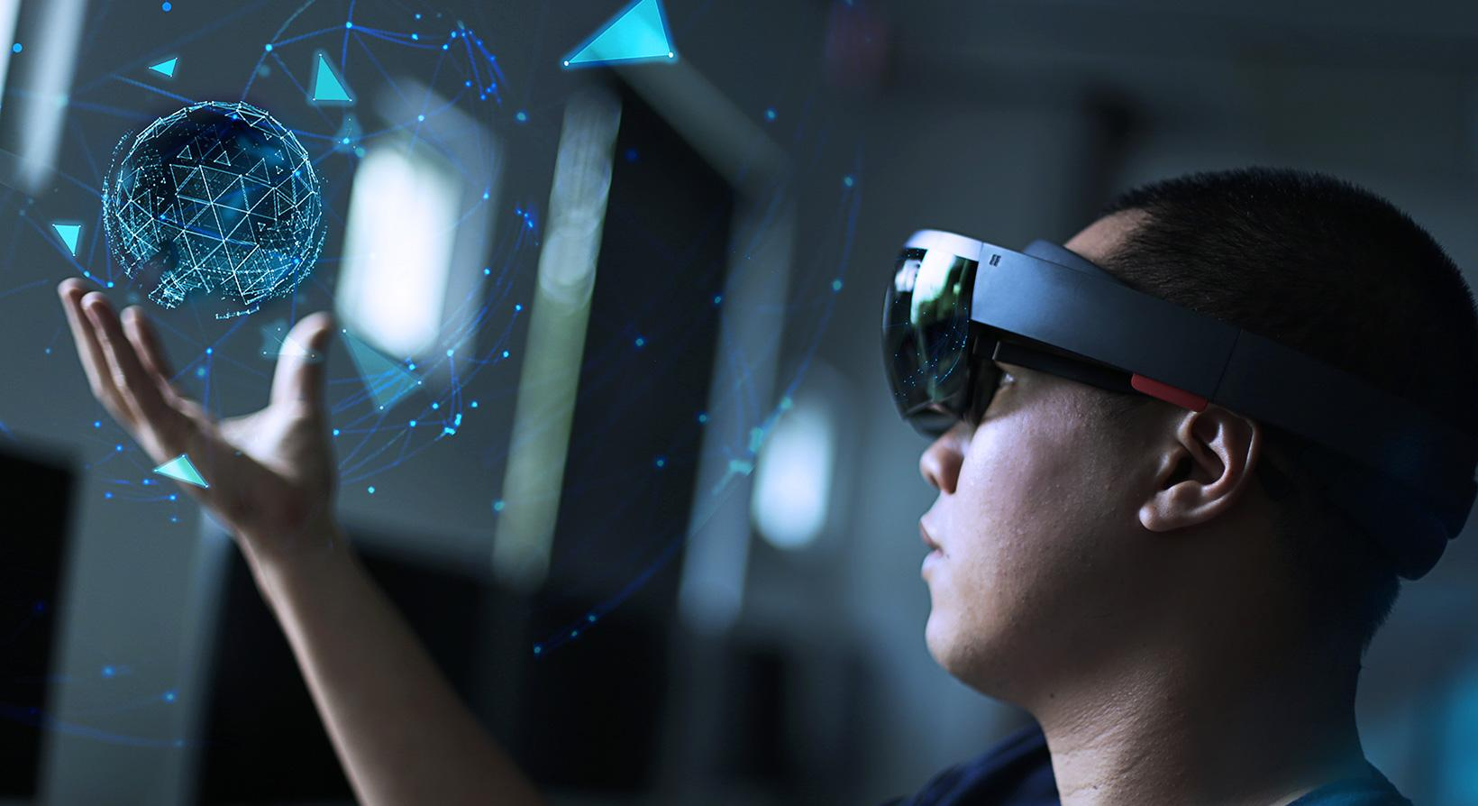

**Prepared by**

**Alekh Meka, Ayaan Siddiqui, Karan Vishwakarma and Masseh Khan**

**University of Illinois Chicago**

**February 2021**

**Table of Contents**

List of Figures …………………………………………………………………………..7

List of Tables .…………………………………………………………………………...8

I Project Description ………………………………….....................................................10

1 Project Overview ………………………………….........................................................10

2 The Purpose of the Project ………………………………………………..……………10

2a The User Business or Background of the Project Effort …………….……………10

2b Goals of the Project ………………………………………....................................11

2c Measurement …………………………………………………………………..11

3 The Scope of the Work …………………………………...............................................11

3a The Current Situation …………………………………...........................................12

3b The Context of the Work ………...…………………………..................................12

3c Work Partitioning …………………………………................................................12

3d Competing Products ………………………………….............................................13

4 The Scope of the Product …………………………………............................................13

4a Scenario Diagram(s) …………………………………............................................14

4b Product Scenario List ………………………………….......................................14

4c Individual Product Scenarios …………………………………...............................15

5 Stakeholders 15

5a The Client …………………………………............................................................15

5b The Customer ……………………………………………………………………...16

5c Hands-On Users of the Product …………………………………………………...16

5d Maintenance Users and Service Technicians ……………………………………...18

5e Other Stakeholders …………………………………...............................................18

5f User Participation …………………………………................................................19

5g Priorities Assigned to Users …………………………………................................19

6 Mandated Constraints 20

6a Solution Constraints ………………………………….............................................20

6b Implementation Environment of the Current System …………………………….21

6c Partner or Collaborative Applications …………………………………………….22

6d Off-the-Shelf Software …………………………………………………………….23

6e Anticipated Workplace Environment ……………………………………………...24

6f Schedule Constraints ……………………………………………………………....24

6g Budget Constraints ………………………………………………………………..25

7 Naming Conventions and Definitions ………………………………………………….25

7a Definitions of Key Terms ………………………………………………………….25

7b UML and Other Notation Used in This Document 26

7c Data Dictionary for Any Included Models …………………………………..........27

8 Relevant Facts and Assumptions ………………………………….................................27

8a Facts ………………………………….....................................................................27

8b Assumptions …………………………………........................................................28

II Requirements …………………………………..............................................................29

9 Product Use Cases ………………………………….......................................................30

9a Use Case Diagrams .…………………………………............................................30

9b Product Use Case List …………………………………......................................31

9c Individual Product Use Cases ………………………………….............................17

10 Functional Requirements …………………………………............................................19

11 Data Requirements …………………………………......................................................19

12 Performance Requirements ………………………………….........................................20

12a Speed and Latency Requirements …………………………………....................20

12b Precision or Accuracy Requirements …………………………………...............20

12c Capacity Requirements …………………………………....................................20

13 Dependability Requirements ………………………………….......................................21

13a Reliability Requirements ………………………………….................................21

13b Availability Requirements ………….…………………………...........................21

13c Robustness or Fault-Tolerance Requirements ………………………………….21

13d Safety-Critical Requirements …………………………………...........................22

14 Maintainability and Supportability Requirements 22

14a Maintenance Requirements ………………………………….............................22

14b Supportability Requirements …………………………………............................22

14c Adaptability Requirements .………………………………….............................23

14d Scalability or Extensibility Requirements …………………………………........23

14e Longevity Requirements …………………………………..................................23

15 Security Requirements …………………………………................................................23

15a Access Requirements ………………………………….......................................24

15b Integrity Requirements …………………………………....................................24

15c Privacy Requirements …………………………………......................................24

15d Audit Requirements ………………………………….........................................24

15e Immunity Requirements …………………………………...................................25

16 Usability and Humanity Requirements ………………………………….......................25

16a Ease of Use Requirements …………………………………...............................25

16b Personalization and Internationalization Requirements 25

16c Learning Requirements …………………………………....................................26

16d Understandability and Politeness Requirements ……………………………….26

16e Accessibility Requirements …………………………………..............................26

16f User Documentation Requirements ………………………………….................27

16g Training Requirements ………………………………….....................................27

17 Look and Feel Requirements ………………………………….......................................27

17a Appearance Requirements …………………………………...............................27

17b Style Requirements …………………………………..........................................28

18 Operational and Environmental Requirements 28

18a Expected Physical Environment …………………………………......................28

18b Requirements for Interfacing with Adjacent Systems ………………………….28

18c Productization Requirements …………………………………...........................29

18d Release Requirements …………………………………......................................29

19 Cultural and Political Requirements …………………………………............................29

19a Cultural Requirements ………………………………….....................................29

19b Political Requirements ………………………………….....................................30

20 Legal Requirements …………………………………....................................................30

20a Compliance Requirements …………………………………...............................30

20b Standards Requirements …………………………………...................................30

21 Requirements Acceptance Tests …………………………………..................................31

21a Requirements – Test Correspondence Summary 31

21b Acceptance Test Descriptions ………………………………….........................31

III Design ……...…………………………………..............................................................32

22 Design Goals …………………………………...............................................................32

23 Current System Design …………………………………................................................32

24 Proposed System Design ………………………………….............................................32

24a Initial System Analysis and Class Identification ……………………………….32

24b Dynamic Modelling of Use-Cases …………………………………...................32

24c Proposed System Architecture ………………………………….........................32

24d Initial Subsystem Decomposition …………………………………....................33

25 Additional Design Considerations …………………………………...............................33

25a Hardware / Software Mapping ………………………………….........................33

25b Persistent Data Management …………………………………...........................33

25c Access Control and Security …………………………………............................33

25d Global Software Control …………………………………..................................33

25e Boundary Conditions 34

25f User Interface …………………………………………………...........................34

25g Application of Design Patterns 34

26 Final System Design …………………………………………………............................34

27 Object Design …………………………………………………......................................34

27a Packages …………………………………………………...................................35

27b Subsystem I …………………………………………………..............................35

27c Subsystem II …………………………………………………............................35

27d etc. …………………………………………………............................................35

IV Project Issues 35

28 Open Issues …………………………………………………........................................35

29 Off-the-Shelf Solutions ………………………………………………….......................35

29a Ready-Made Products …………………………………………………………..35

29b Reusable Components …………………………………………………..............35

29c Products That Can Be Copied …………………………………………………..36

30 New Problems 36

30a Effects on the Current Environment …………………………………………….36

30b Effects on the Installed Systems ………………………………………………...36

30c Potential User Problems …………………………………………………...........36

30d Limitations in the Anticipated Implementation Environment That May Inhibit the New Product 36

30e Follow-Up Problems …………………………………………………................36

31 Migration to the New Product 37

31a Requirements for Migration to the New Product ……………………………….37

31b Data That Has to Be Modified or Translated for the New System 37

32 Risks …………………………………………………………………………………....37

33 Costs …………………………………………………………………………………....37

34 Waiting Room …………………………………………………………………………..37

35 Ideas for Solutions ……………………………………………………………………...37

36 Project Retrospective …………………………………………………………………...38

V Glossary …………………………………………………………………………...…...38

VI References / Bibliography ……………………………………………………………...38

VII Index …………………………………………………………………………………...38

### 

### List of Figures

*Fig 1.1* *- Working environment of components……..*…....……………………………………….21

*Fig 1.2* *- Scope event scenario diagram…….……….*…....……………………………………….14

*Fig 1.3* *- Implementation environment for the Virtual room*….………………………………….21

### 

### **List of Tables**

*Table 1 - Product Scenario List* ………………………………………………………………….14

# Project Description

## Project Overview

Virtual Room is a product that utilizes the tools found in Machine Learning and Software Engineering. The main objective of Virtual Room is to provide a virtual environment for users to enhance their communication and interaction with other users while in the comfort of their home, also following safety guidelines. Since Virtual Room is based around COVID, we ensure the safety and social distancing norms of the COVID-19 pandemic while enabling realistic interaction among users.

## The Purpose of the Project

Due to the emergence of the COVID-19 pandemic, people have to emulate the strict principles of social distancing to avoid spreading of the virus. This had a tremendous impact on the social, emotional and professional lives of the people. With every activity carried out through the internet, group activities have been lost and cannot be carried out, and even if they are, the dynamic is much different and creates lots of complexities. Virtual Room was designed with this in mind, and therefore, helps to provide a solution to bridge this gap in society.

### The User Business or Background of the Project Effort

Users could utilize Virtual Room for personal and professional uses. In terms of professional / business use, Virtual Room can be utilized to simulate a courtroom for example.

**Content**

Lawyers, judges, defendants, the jury and the judiciary system at large would benefit greatly from a virtual courtroom setting.

**Motivation and Considerations**

Currently, while we are in the midst of a global pandemic, courtrooms in the United States have been closed and hearings are taking place virtually via zoom. However, this is very limited and only allows a few people to see each other’s faces. Even if you were to have the jury and more than 15 users participating for example, a single user can only focus on one person at a time. If they are used to the zoom format, they might be able to fit 4 users on their screen, while seeing and hearing everyone adequately. With Virtual Room, you can have everyone present and participating in one room. The judge can look between the lawyers and the defendants with ease, the lawyers can freely present their evidence to all spectators and the jury will clearly be able to observe the trial.

### Goals of the Project

People all round the world have been adversely affected by the pandemic in various aspects like socially, emotionally etc. Not being able to meet their loved ones had separated people and caused many problems. Keeping this problem as a foundation, a virtual room helps to enhance the mental and physical well being of the users and provide a virtual environment where people can interact with each other efficiently.

**Content**

Virtual Rooms help in providing a user friendly virtual environment for people to gather and interact with their family and friends, to keep in touch with colleagues, and add a different dimension to their lives affected by COVID-19.

**Motivation**

Through our product, a virtual environment would be set up to enhance the communication between the different users. Virtual Rooms would be able to balance their social and emotional wellbeing of a person and keep his or her life connected with the world. To ensure the scalability of the product, the architecture of the product will be able to support any environment where the user is in currently.

### Measurement

The main goal of Virtual room revolves around customers well being from pandemic and providing an environment having enhanced tools for communication. Keeping the customers satisfaction as a priority, Virtual rooms will ensure a constant service to the users. Special hardware gloves equipped with tactile sensors will be made available online for people to purchase. These gloves will be used to enhance the user experience during the virtual environment.

Users will be able to rate the product and provide feedback on various aspects based on aspects like Usability, durability of the product, on the website etc. These statistics will help our team to get a comprehensive report on the product. Additionally, the mobile application will request the users to give feedback after every 15 days with questions on their current health status. These checks will help us estimate the total number of users who are safe from covid and they are able to remain unaffected after 15 days. This percentage will help us to ensure whether we are able to fulfill our goals of our product and team.

## The Scope of the Work

As Virtual Room is a very versatile product, the scope of it’s work is quite broad. It will be used for personal and professional use. The product itself can be used in any location.

### The Current Situation

In order to meet their regular requirements for work, school, or personal matters during this global pandemic, people are scheduling meetings on online platforms like Zoom, Google Hangouts and Microsoft Teams. Schools, like our school University of Illinois at Chicago, have been using platforms like blackboard and acadly.

**Content**

These platforms all work very similarly. Users will join a virtual meeting with 1 or more people and communicate via their phone or computer’s audio. They also have the option to turn their camera on. While this method of communication is greatly improved over just having a chat forum or email thread, it is not ideal for many of our use cases today.

**Motivation and Consideration**

These platforms provide a basic interaction but lack a lot of aspects which are included in personal meetings. A lot of people still feel disconnected, as all they see during these meetings is the other person’s face, if their camera is on, or their voice. For many meetings and events, just seeing a video feed of someone’s face is not sufficient. Courtroom sessions, as we mentioned earlier, fall into this category. Another prime example would be sporting events, such as NBA games or NFL games.

### The Context of the Work

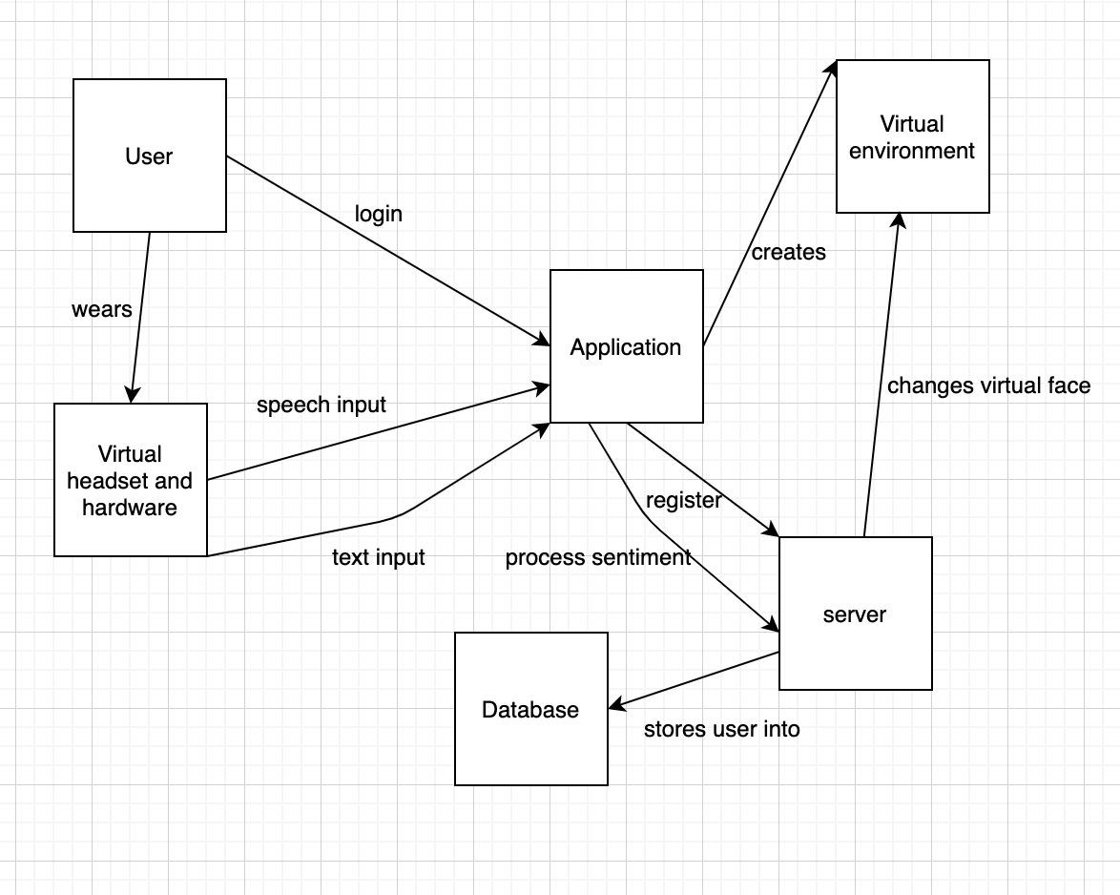

Fig 1.1: Working environment of components

### Work Partitioning

The work that the user would have to do is very simple. They would download the application on their phone, tablet, or computer. They would then sign up using their email address or phone number initially. If the user is signing into an organization (work or school for example) , then they would use their work / school email. There would be a device that comes with a virtual room ( a small hand-sized device) that one would place down to virtually simulate whatever environment / meeting that they will be joining or hosting. The users can then create or join a meeting via the application. When they have finished, they will close the application.

### Competing Products

Currently virtual room has no real competing products. If you want to consider alternatives to what virtual room provides, zoom and the meeting programs we mentioned earlier can be mentioned, so we will address them as if they were competing products.

**Content**

Zoom, Blackboard, Google Hangouts, and Microsoft Teams can be used to hold virtual meetings. However, as we mentioned earlier, they are very limited. The maximum interaction you will have is hearing their voice, seeing their face, and seeing their screen if they share it to present something for example.

**Motivation**

If the customer wants more interaction in their meetings, or for example if the customer is a whole organization and wants the option of having more interactive meetings available for all of their employees, then they will choose our product. If they are content with the limited communication present in Zoom for example, then they might stick to Zoom.

**Considerations**

One option we might be able to incorporate within our software, is the option to have basic virtual meetings like Zoom and Microsoft Teams do. If the employees of a business want to have a quick short meeting that doesn’t require the full features of Virtual Room, then they are able to do so. Having this option, along with competitive pricing, will give us the edge over these other platforms.

## The Scope of the Product

Let’s consider a scenario where a family continues the tradition of celebrating a holiday at their grandparents house, where all the members of the family come over from different states to celebrate and get together. However, due to the COVID restrictions they will not be able to gather at one place. In this case, with the current services we have available, the closest this family can get to experience their face to face gatherings would be via video conferencing, with products like Zoom, Skype, etc. This where Virtual Room truly shines as a very unique platform that aims to solve these problems. In this case, the user can create a virtual environment using the phone camera and recording the environment he/she wants the meeting to be, they will also be able to add props, games, movies, and any other form of entertainment. Once the environment is set up, they can invite friends and family to join in. Once everyone is connected, they will be able to fully interact with other members present in the room, this provides a much better experience than just a regular video conference, as Virtual Room offers interactive VR games, movies that everyone in the room can watch in sync, etc.

### Scenario Diagram(s)

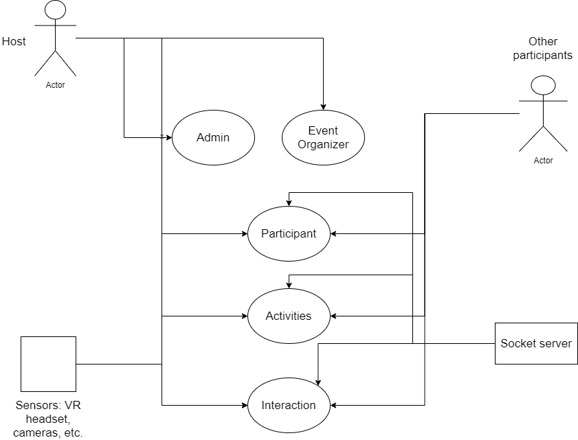

Fig 1.2: Scope event scenario diagram

### Product Scenario List

|  |  |
| --- | --- |
| **Scenario** | **External actors** |
| Birthday party | Users attending the party, VR sensors, camera, DB, socket server to connect users |
| Sporting event | Players, teams, event organizers, advertisers, audience, servers, interactions with other members, special VIP seatings |
| Wedding | Bride, groom, audience, programs, event organizer |

### Individual Product Scenarios

* **Birthday party scenario:** In this scenario, we have a different audience and the person(s) whose birthday it is. In addition to this, we also have events in this party, games, and other activities created by an admin, host, or event organizer.
* **Sporting event:** In this scenario, we have a sports event, like the Super Bowl. In such a large scale event, there will be thousands, if not millions of people. In such a scenario we will have hundreds of advertisements, halftime shows and other activities. In events that are this large there will be teams of event organizers, team of admins, and a team of hosts. There will also be special VIP audience members.
* **Wedding event:** In this scenario, we have a wedding with a bride, groom, audience, admins, event organizers, hosts, and other special positions can also be assigned by the admins, and hosts. The admin, host and event organizers create and set up the main wedding event. The audience will be able to see the entire event also take part in all the other activities, like cutting the cake, ring ceremony, and any other cultural parts added as activities by the event organizers.

## Stakeholders

Virtual Room consists of a variety of stakeholders involved in the product and its development for the future. Individuals and families can choose to purchase the product for personal communication needs. Businesses and corporations can supply their employees or audience with Virtual Room so that they can efficiently convey conversations.

### The Client

This project consists of several clients that could potentially invest in this product. Since precision and accuracy are a high priority for our machine learning algorithm, we hope to attract clients that have a strong reputation for research in those domains.

**Content**

Being the leader in machine learning, Google is the prime target for our project. Artificial Intelligence is a very strong research domain at Google. Another potential client is Facebook because of their recently made VR headset “Facebook Oculus”. We believe that both clients can provide the resources necessary to develop a high quality product that meets the needs of our customers.

**Motivation**

Both clients will have intrinsic and extrinsic motivation for developing our product. Since the ideals of Google and Facebook center around improving the well-being of individuals in society, they will be intrinsically motivated to create a product that can significantly improve the quality of virtual communication. They will also be extrinsically motivated because this is a huge opportunity to create a product that will be in demand by personal users as well as by businesses. Ideally the primary objective at launch will be to improve productivity in the workplace. This will be easily testable to show the tangible benefit it can provide to a business. Once there are enough statistics to show a strong correlation between our product and improved communication, we can launch for personal use.

**Considerations**

Our product is focused heavily on providing a high-quality holographic rendering for each user. We want to create a realistic experience that envelops our user into a familiar environment. Although initial costs may be expensive, the objective is to provide the highest quality communication mechanism available in the market.

### The Customer

Our product targets several types of consumers. Business consumers will provide most of the sales but personal consumers will also obtain a huge benefit from purchasing our product.

**Content**

Our initial customers will be 3rd-party business entities with the end user either being the customers of an event or the employees within the company. Virtual Room is intended to be used for large social gatherings such as the Superbowl. Virtual Room is also used for communication between the employees in the firm. The other type of customer that our product hopes to cater to is personal users. With our virtual reality rendering, we can connect individuals in a family together regardless of the distance between them.

**Motivation**

Since the client will be either Facebook or Google, we will provide productivity statistics from the use of Virtual Room at the company offices. After those statistics have been generated, we hope to sway other companies to purchase Virtual Room for the productivity needs of their employees. The value this product brings to the communication between the organization greatly outweighs the cost to purchase it for each employee. For personal users, they will be motivated to purchase this product if they want to have realistic, high-quality experiences with their loved ones that live far away.

### Hands-On Users of the Product

**Content**

1. User name/category: Attendees of a social event

User role: The typical social event such as the Superbowl is very dangerous amid the current pandemic. The user can avoid the dangers while enjoying the event through our product. They will simply download the application, and launch the holographic generator that is sold with our product.

Subject matter experience: The user can be a novice and not know much about Football or the event that they are attending while still enjoying the event through social interaction.

Technological Experience: The user can be a novice at using this device and still have a memorable social experience. There will be an automated AI that you can speak to that will take care of many of the technical nuances.

Other User Characteristics: Extremely broad range of users. Initially tailored to primarily English speakers.

1. User name/category: Employees from the business entity

User role: The employees from a business can use this product to communicate and present ideas among one another. This application should be easy to use for a non-tech savvy individual in the company. The user simply has to download an application on their phone and scan the surroundings. Then the app connects to the holograph generator and presents a display that mirrors an environment.

Subject matter experience: The user can be a novice in the particular business that they are in and still reap the benefits of this software. This is designed to foster healthy communication that they would normally experience face-to-face. This healthy communication helps create an environment where users can effectively learn.

Technological Experience: The user can be a novice at using the device and still manage to get a high quality experience. The software takes care of many of the nuances that come with virtual displays. However, if the user is experienced, they can make additional modifications in the settings.

Other User Characteristics: Ideally we would be targeting this to an age group between 20-49. These individuals are typically the most reliable when dealing with technology. The benefit is that only one holograph generator is needed for a room. Thus, many of the other users will just need to download the software so that they can use it.

1. User name/category: Personal Family Users

User role: The individuals in a family can use this product to communicate with one another despite being a large distance away from each other. The user simply has to download an application on their phone and scan the surroundings. Then the app connects to the holograph generator and presents a display that mirrors an environment.

Technological Experience: The user can be a novice at using relevant technology but still manage to experience sentimental and valuable conversations with other individuals. There will be a separate “personal” version of the software that will be more user friendly and allow the user to speak to their device and get set up.

Other User Characteristics: This version of the software should be easy to use for individuals among all age groups and genders. By simply speaking to their device, the software will connect them to their requested user and present the environment that they desire.

Our first hands on users will be the employees from our initial business corporations that choose to use Virtual Room as a productivity enhancer. Our product should be catered to meet all the needs that a business has during a meeting, including the ability to present slideshows, virtual podiums and other mechanisms. Our second hands on users will be family members that are trying to communicate among each other over a large distance. Through this product, they maintain the sentimental relationships with their loved ones despite experiencing change throughout their life.

### Maintenance Users and Service Technicians

**Content**

For this product we need to have a variety of maintenance users and service technicians for different parts of the product. The existing virtual reality renderer should be improved each year as the current technology improves. The UI of the application should also be updated yearly with new features added as new ideas are developed. The code should be refactored each year to handle new demands in traffic to the application.

**Motivation**

Through this analysis we realize that we need to hire skilled developers to maintain the legacy code because it will need improvements to avoid staying out-of-date. It will also need to handle a large amount of traffic effectively.

### Other Stakeholders

**Content**

Other potential stakeholders in this process could be project managers from a variety of companies that would like to purchase the product.

**Motivation**

The motivation for many of these smaller companies will be if the benefits outweigh the overhead costs of the product. After seeing the productivity growth in larger companies, many of the smaller companies may be motivated to be involved in the process.

### User Participation

**Content**

During the process, there will be a feedback section after each meeting that allows the user to address any concerns or issues they had during the virtual meeting. Through this feedback step, we are able to consistently improve our products and generate new ideas on a regular basis.

**Motivation**

The motivation behind this step benefits both the users and the developers. The users can address new features that they would like to have or issues that they are currently having. The developers can build an application that effectively scales to the needs of the consumers.

### Priorities Assigned to Users

**Content**

Key users: Social Event User, Business Employees, CEOs

Secondary Users: Families

Unimportant Users: -

**Motivation**

The highest priority for this product is to provide a safe and interactive way for individuals to attend social gatherings while adhering to social distancing guidelines and staying safe. Another high priority for this project is to present an effective solution to virtual business meetings that preserves the sentimentality found in face-to-face conversations. The target users for our product will be business employees because we hope to improve productively and provide a better communication mechanism between the employees. Families will also be using this product but we will prioritize its use in a formal setting over the family setting.

## Mandated Constraints

### Solution Constraints

Virtual rooms help to provide the services with limited number of constraints for better usability for the customers.

**Description:** The virtual headset utilized by the user should have a Graphical Processing Unit (GPU) enabled with video decoding processes like Inverse Quantization.

**Rationale:** To enable a smooth animation and transition of virtual objects in the environment and to prevent latency in communications.

**Fit Criterion:** The user shall be able to enter the virtual environment with commercial VR headsets available in the market.

**Description:** The product utilized for communication needs to be lightweight.

**Rationale:** For long hour meetings, the headset and sensor gloves need to weigh less, and need to be ergonomic, such that it doesn’t cause headache or muscle strains while wearing them.

**Fit Criterion:** The weight of the headset should be less than 510g to ensure that users can wear them comfortably for a long period of time without getting a headache.

**Description:** The mobile operating system should have an updated version of Android operating system.

**Rationale:** Earlier versions of Linux have deprecated methods and libraries which hinder with the working of the application. These methods become vulnerable to cyber attacks and might jeopardize confidential information.

**Fit Criterion:** Linux operating kernel of more than API 21 (Kitkat) is preferred for running the software on the mobile device.

### Implementation Environment of the Current System

**Content**

Virtual rooms can be installed in mobile devices through the android operating system. The application will be supported for different versions of Android OS (minimum support API 21).

**Examples**

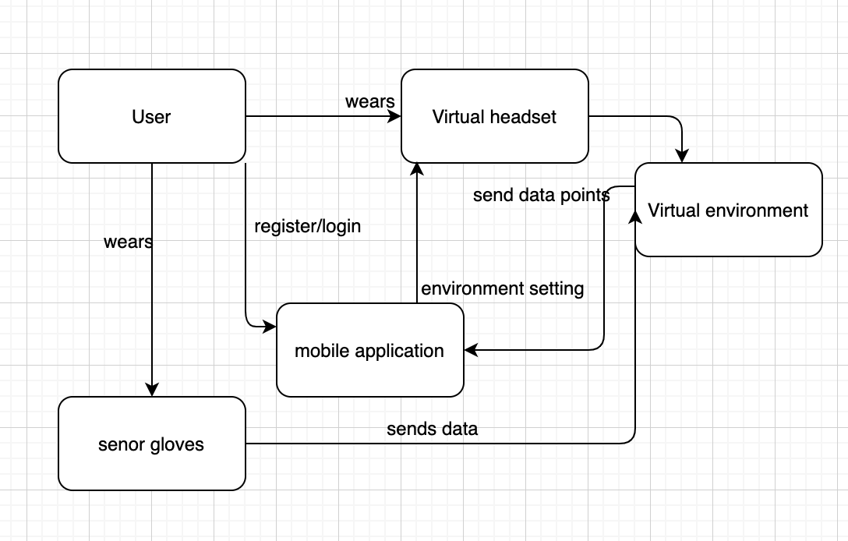

Fig 1.3: Implementation environment

### Partner or Collaborative Applications

**Content**

Virtual rooms provide a smooth transition for the new users who initially register for the application. Users can utilize other social media platforms like Facebook, Twitch, hangouts, Google account, etc to register from their mobile application.

**Motivation**

With increase in internet application and diverse online platforms, users prefer to opt in new services with existing platforms. To include this functionality the architecture of Virtual room is designed to collaborate with other social media platforms and hardware configurations.

**Examples**

The mobile application will be implemented with a separate 2F authentication to ensure that there are no fake users or ID which are used to login inside the application. With integration with Facebook, many user accounts will be duplicate and fake. To tackle this problem, a unique token will be provided to users based on their mobile number as a mapping key which will help to ensure the credibility of the user. In case the user loses his or her phone then proper recovery methods will be integrated inside the application.

The gloves sensors utilized for enabling tactile sensors can be enhanced by collaborating with companies like Omron. With advanced health monitoring devices, Virtual rooms will be able to keep track of the motion as well as vitals of the users to ensure what the user is touching and feeling while interacting with others. The data types recorded from the sensors can be altered based on the type of sensor involved.

For running the application smoothly without any interruptions, other applications in the mobile phone can be emptied from the application stack so that there are no notification and alert messages while running the application. Background and foreground services needed to be requested to pause while the application runs.

**Consideration**

The configuration for permission required might change depending on the type of company, such as Xiaomi, OnePlus, Windows phones etc, which run on Android operating systems. These exceptions are considered inside the Virtual rooms application for better scalability.

### Off-the-Shelf Software

**Content**

Inclusion of some Off-the-Shelf software and hardware is required for facilitating smooth communication among users.

**Motivation**

The interfaces and design patterns of the virtual rooms are enhanced by inculcating software and hardware sensors to make the interaction realistic. Use of additional softwares which users find more convenient and are easy to integrate for the Virtual Rooms product.

**Example**

For the Virtual room software mobile application, the functionalities of the user interface and animating the video will be integrated using build-in drivers and Native SDK libraries of Android. The Camera Drivers of the C/C++ libraries will be utilized for faster processing of video and serialization of the video for network transmission.

To make the virtual environment realistic, the virtual headsets need efficient video decoding configurations. Various other headsets available in the market like Oculus, Microsoft, Unity etc can be utilized, depending on the software configuration of the product. The latest Oculus Quest 2 with a Snapdragon XR2 system-on-chip has the sufficient hardware configuration including the RAM, which supports the memory requirement for presentation of virtual face expression in a variety of softwares and games.

Additionally, as a part of the hardware need, senor gloves are worn by users to enable the tactile movements in the virtual setting.

### Anticipated Workplace Environment

**Content**

The internal virtual environment of the Virtual room is selected by the user based on the theme and the type of meeting. On the other hand, the important aspects of using this product is the compatibility to use it in a variety of environments. Virtual rooms are compatible with environments which may include libraries, offices, home, trekking areas, conveyance vehicles like cars and busses, etc.

**Motivation**

For Virtual rooms to deliver the functionality based on the requirements of the users, the hardware and software need to comply with the environmental changes around. To make the accessible

**Examples**

For using a virtual room in quiet places, the virtual headset will have an inbuilt microphone and ear pieces which will help to listen to conversations privately without disturbing anyone else.

Since some products are not water resistant, getting in contact with water might make the display blur and cause the circuit boards to malfunction. Virtual room integrated powerful glues to join hardware components and rubber gaskets around the ports to ensure water doesn't damage the product. As a result, users can comfortably use the product in damp environments. For supporting noisy background, the earphones will be able to produce a vacuum so that the outside noises are blocked, and the user is able to hear the conversation of other participants in the virtual environment.

**Consideration**

For avoiding any hindrance in the work environment, the hardware and software of virtual rooms are tested as per the needs of the users. Different environments are taken into consideration prior to securing all the requirements needs of the users.

### Schedule Constraints

**Content**

To meet the basic requirements and needs of different components of the product the different development releases must synchronize and work with other components of the system. Virtual Rooms is based on agile methodology to ensure an iterative increment of the product functionality.

**Motivation**

The virtual headset used for entering the virtual environment needs to be in sync with the latest updates of the mobile application being used. Failure in this requirement might induce some latency in processing the virtual expression and performing the required sentiment processing from the text.

**Example**

The user interface of the mobile application needs is completed incrementally in cycles of 2 to 3 week starting from the first week. The application will be segregated in components and prioritized based on the needs of the user. The virtual environment needs to be tested which has a deadline before the initiation date of the next cycle to verify whether it aligns with the requirements.

What would happen if the deadlines are not met or the incremental product is not built?

For the initial development of the product, the investment will be made on the software developers to develop the UI of the application and the hardware components. To meet with the losses of not meeting the deadline, the team will try to prioritise the functionality which will ensure the fulfillment of different requirements of the application. Due to extensive sales on the products on festivals, a marketing strategy will be adopted which will attract more and more customers to buy the product in the upcoming season.

### Budget Constraints

**Content**

Virtual rooms will help to provide the required virtual environment by integrating the software and hardware.

**Motivation**

The different components required for the end product will be predicted to get an estimate whether it meets the requirement and meets the budget at the same time.

**Consideration**

For the hardware requirements, the virtual headset hardware will cost around $120 with the sensor gloves (including all the tactile sensors) around $50. The virtual headsets of different companies like Facebook, Samsung and Google are compatible with Virtual Rooms which can reduce the cost for users already having VR headsets. The mobile application will be readily available for free in the PlayStore with supported functionalities.

Is it realistic to build such a product?

Virtual rooms aim at providing a realistic virtual environment by integrating existing technologies of Machine Learning and Virtual reality. As a result, it provides a totally different experience with enhancing the existing tools and the production cost can be kept in limit for the requirements to be fulfilled comprehensively.

## Naming Conventions and Definitions

### Definitions of Key Terms

* **Audience:** This can be a little vague depending on the context. For example, the host can also be an audience member, in family gatherings. But for like a sporting event the host does not have all the functionality that an audience member might have, and might have other administrative features.
* **Host:** Similar to audience, the term host might also be a little ambiguous, as for certain events the host might also want to be an audience member with special privileges, and in other cases the host might only be able to have an overview of what is going on in the room and is able create games and other events.
* **Room:** A room is simply the place where the specific event takes place in. For example a room could be a courtroom, or a stadium.
* **Activities:** An activity is anything that takes place within the room. For example games that were added to the room would be considered activities.
* **Oculus:** VR headset company created by Facebook, that allows developers to make games and other VR related products.
* **Event organizer:** An event organizer can be the host, admin, or even part of the audience. The main job of the event organizer is to manage all the activities, and the setting of the room. Including inviting the audience members. The event organizer is set by the admin or the host.
* **Admin:** The admin is appointed by the host and is able to oversee all parts of the event and can also be part of the audience. The admin can be the host, event organizer, and even the audience member.
* **Event organizer:** An event organizer is a term used to describe all parties that helped in organizing the event. An admin, host, event organizer are all considered event organizers.
* **Event:** An event can be used to describe a room, and can be used interchangeably.

### UML and Other Notation Used in This Document

* 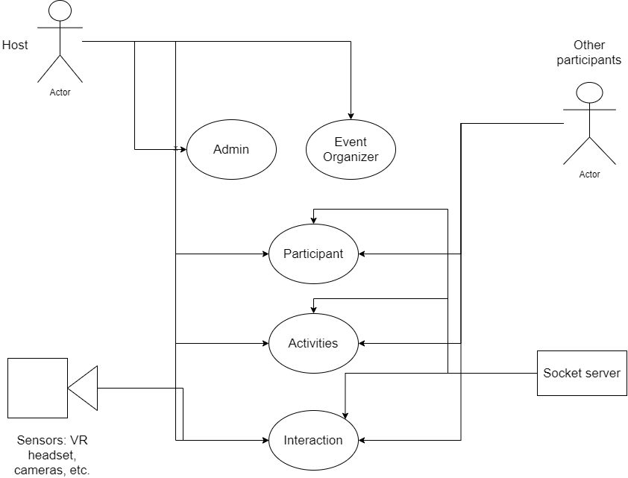 This object represents an actor, specifically a user actor. This can be an admin, event organizer, etc. This object could also represent multiple audience members.
*  This object represents any sensor that the user has to use in order to make the VR work, or a sensor that will make the experience better. This object is only used in a single diagram.
*  This object is used to represent any kind of server. In the scenario diagram this is used to represent a socket server that will be used to communicate with fast response times.
*  This object is used to describe use cases in the case of the scenario diagram this object is used to represent an activity/activities.

### Data Dictionary for Any Included Models

Since the majority of our data comes from a database, we will not need to utilize many different data structures other than Lists and Maps. Anytime the program needs to loop over data fetched from the database we will almost always use a list data structure since it is the best one to use when looping over data. Anytime we need to store data that has to be searched either now or in the future any Map data structure is the most suitable (HashMap, TreeMap, etc). Other than this, Virtual Room will most likely be relying on software like ElasticSearch or Algolia for full-text search.

## Relevant Facts and Assumptions

### Facts

**Content**

* This product needs to effectively implement a socket server to handle a high amount of traffic with minimal delay in sending and receiving packets of information.
* The primary objective will be to improve productivity in the workplace
* Almost all body language expression is lost with current communication mechanisms
* VR headsets have been used frequently but holographic projections are very infrequently used in current society

**Motivation**

The motivation behind all of these facts is the necessity for our product to be presented as an effective high-quality solution for the new era of communication. As there becomes an increased need for digital communication, we provide a unique solution to the everlasting problem.

### Assumptions

**Content**

* Virtual Room is not reliable for any misuse of the product
* The holograph generator should be away from any liquids
* The holograph generator should be at least 3 feet away from any objects
* The holograph generator should be put in the middle of a room to generate an effective holographic display
* The Virtual Room is not responsible for any emergency calls or meetings with the local police department
* All meetings are immediately discarded unless the user has specified a cloud storage option to upload to

**Motivation**

Virtual Room intends to provide a safe and effective meeting platform. There are several safety precautions to follow when using the holographic generator. Virtual Room is not liable for any damages caused by misuse of the product.

**Examples**

Virtual Room is not intended for any lawful purpose and cannot be used in the courtroom as viable evidence.

The holographic generator needs to be in a location that avoids moist surroundings and has at least 3 feet of space away from other objects.

Our products are consistently being reengineered to improve with the current technologies.

The project will effectively manage a team of highly trained developers that carry out different aspects of the objective.

**Considerations**

These assumptions are intended to provide a safety net for the individuals involved in creating Virtual Rooms. These assumptions are also intended to protect the individuals that are using the product. Although there may be competing products that try to replicate our ideas, we will manage to outperform them through our efficient team and instilled values. Since we plan to work with a client that has experience in the technology industry, we hope to generate a very high quality product that meets all the needs of our consumers.

# Requirements

*SV: Sections 9 and 10 deal with functional requirements. Sections 11 to 20 are a very thorough list of possible non-functional requirements, not all of which apply to every project. You should think carefully about each of these, form requirements if applicable, or write “Not Applicable” otherwise. See section 10 for the format of individual requirements. Section 21 documents the acceptance tests planned to verify the requirements – See that section for further details, and be aware that every requirement needs at least one verifying acceptance test ( though some tests may verify more than one requirement. )*

## Product Use Cases

*SV: Product Use Cases are very similar to Product Scenarios, but in more formal detail. They serve as a first step towards developing functional requirements, and can aid in organizing requirements according to the use case(s) from which they were developed. See the CS 440 web site for a sample use-case form, with instructions.*

### Use Case Diagrams

*SV: Use case diagrams list the use cases developed for a system, mark the boundary of what is internal or external to the system to be developed, and indicate which external entities ( actors ) are associated with each use case.*

*Examples*

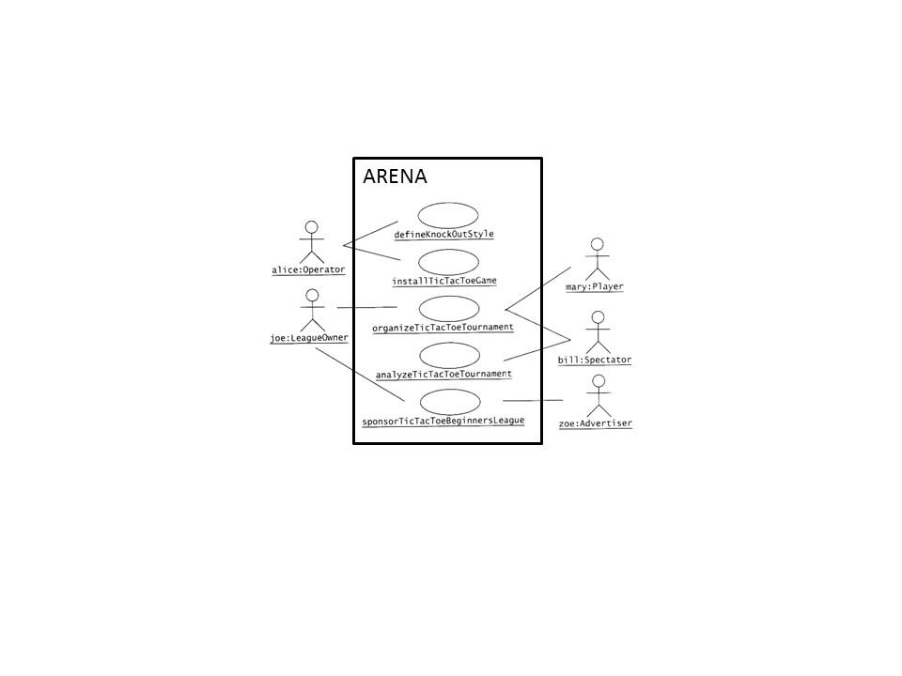

**Figure 1 - Sample Use Case Diagram from Bruegge & DuToit ( modified )**

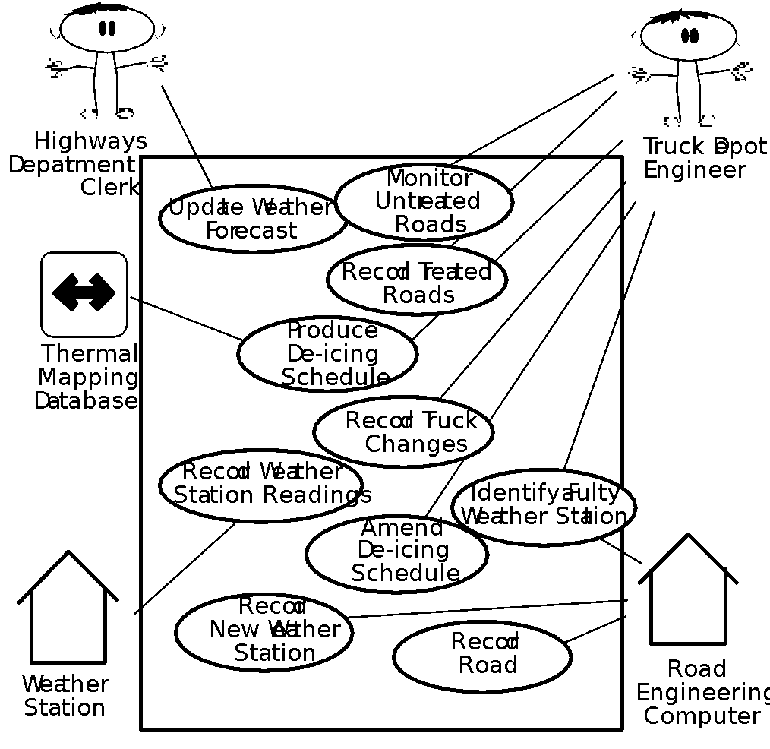

**Figure 2 - Sample Use Case Diagram from Robertson and Robertson**

### Product Use Case List

*SV: A list ( table ) of use cases is an alternative to the use case diagram, particularly when there are many use cases. There may be additional information in the table not found in the diagram, such as cross referencing to other sections or materials.*

### Individual Product Use Cases

*SV: The following example was copied from “useCaseFormWithInstructions.docx”, available on the CS 440 web site. ( There is also a blank version available. )*

|  |
| --- |
| Use case ID: Name:  pre-conditions:  post-conditions:  Initiated by:  Triggering Event:  Additional Actors: |
| Sequence of Events:   1. Initiating event or action should be step 1, taken by initiating actor. 2. System response follows, indented right. 3. All external action steps are aligned with step 1. ( "stimulus" style ) 4. All system responses are indented right, aligned with step 2. ( "response" style ) 5. All steps should be expressed in the active voice, clearly indicating **who** performs each action 6. The sequence of events should show a back-and-forth stimulus-response relationship. |
| Alternatives: These would be normal and expected variations from the base case.  Exceptions: These would be unusual variations from the base case, often caused by problems. |

* *For all of the above, list as NA if not applicable.*
* *The following may be added if relevant, or omitted otherwise:*
  + *related use cases or scenarios*
  + *associated tests, systems, classes, etc.*
  + *revision history*
  + *references to other documents*
  + *author(s) / originator( s )*
  + *notes*
* *Alternatives and Exceptions may be listed either as separate use cases or as notes to a base case, depending on their significance and similarity.*
* *For regularly occurring periodic events, "time" can be listed as the initiating actor.*

## Functional Requirements

*SV: Each requirement listed needs to have a unique identifier, a short name, a one- or two-sentence description, a rationale, a fit criteria, and reference to one or more acceptance tests to be used to confirm the completion of this particular requirement. The acceptance tests themselves are documented in section 0- See that section for further details. It is recommended to number the requirements according to their type, such as F-4 for the fourth functional requirement or U-2 for the second usability requirement. Functional requirements specifically deal with the functionality the system must have, and are generally derived directly from the steps the system takes during use cases.*

**ID# - Name**

**Description:** Your description here . . .

**Rationale:** Your rationale here . . .

**Fit Criterion:** Your fit criteria here . . .

**Acceptance Tests:** List ID# and/or names here . . .

## Data Requirements

*SV: Data requirements deal with requirements that are somehow related to data, such as the definition of what is included in a “student record” or the acceptable form of an e-mail address or allowable range of certain data items.*

**ID# - Name**

**Description:** Your description here . . .

**Rationale:** Your rationale here . . .

**Fit Criterion:** Your fit criteria here . . .

**Acceptance Tests:** List ID# and/or names here . . .

## Performance Requirements

### Speed and Latency Requirements

*SV: Requirements specifying how fast ( or slow ) the product must operate or how much lag is allowable between stimulus and either initial response or task completion. Other timing-related requirements could go in this section.*

**ID# - Name**

**Description:** Your description here . . .

**Rationale:** Your rationale here . . .

**Fit Criterion:** Your fit criteria here . . .

**Acceptance Tests:** List ID# and/or names here . . .

### Precision or Accuracy Requirements

*SV: Self-explanatory. How accurate or precise must the system be.*

**ID# - Name**

**Description:** Your description here . . .

**Rationale:** Your rationale here . . .

**Fit Criterion:** Your fit criteria here . . .

**Acceptance Tests:** List ID# and/or names here . . .

### Capacity Requirements

*SV: Requirements regarding the largest “thing” the system must be able to handle, or perhaps how many things it can handle ( at once. ) Note: Requirements regarding how many things it can handle in a given time period would be a speed requirement, covered in section 12a above.*

**ID# - Name**

**Description:** Your description here . . .

**Rationale:** Your rationale here . . .

**Fit Criterion:** Your fit criteria here . . .

**Acceptance Tests:** List ID# and/or names here . . .

## Dependability Requirements

### Reliability Requirements

*SV: Reliability relates to how frequently the system fails, ( either by shutting down or by delivering erroneous results ), and the consequences of those failures. These requirements may also address the conditions under which it is allowed to fail ( or not. ), See also availability and robustness in the following sections.*

**ID# - Name**

**Description:** Your description here . . .

**Rationale:** Your rationale here . . .

**Fit Criterion:** Your fit criteria here . . .

**Acceptance Tests:** List ID# and/or names here . . .

### Availability Requirements

*SV: Availability addresses the amount of time the system is running and available for use. It is affected by how often the system goes down ( reliability ), but also by the time required to bring the system back up again, the availability lost due to regularly scheduled maintenance down times, and the ability of the system to offer at least partial functionality in the face of failures or resource shortages. See also reliability and robustness.*

**ID# - Name**

**Description:** Your description here . . .

**Rationale:** Your rationale here . . .

**Fit Criterion:** Your fit criteria here . . .

**Acceptance Tests:** List ID# and/or names here . . .

### Robustness or Fault-Tolerance Requirements

*SV: This section deals with the system’s ability to provide at least partial functionality in the face of failures or resource shortages, such as operating in offline mode when network connectivity is unavailable. See also reliability and availability.*

**ID# - Name**

**Description:** Your description here . . .

**Rationale:** Your rationale here . . .

**Fit Criterion:** Your fit criteria here . . .

**Acceptance Tests:** List ID# and/or names here . . .

### Safety-Critical Requirements

*SV: These requirements address potential harm to health, safety, or property, and may refer to relevant standards such as OSHA compliance.*

**ID# - Name**

**Description:** Your description here . . .

**Rationale:** Your rationale here . . .

**Fit Criterion:** Your fit criteria here . . .

**Acceptance Tests:** List ID# and/or names here . . .

## Maintainability and Supportability Requirements

### Maintenance Requirements

*SV: This section deals with the ease with which the system can be maintained, and possibly who will perform system maintenance and under what conditions. The ease of evolving the system into future versions may also be addressed here, or in a separate section ( not included in this template ) if that is a major concern.*

**ID# - Name**

**Description:** Your description here . . .

**Rationale:** Your rationale here . . .

**Fit Criterion:** Your fit criteria here . . .

**Acceptance Tests:** List ID# and/or names here . . .

### Supportability Requirements

*SV: What ongoing support is to be provided, e.g. through a help desk. See also training requirements in section 16g below.*

**ID# - Name**

**Description:** Your description here . . .

**Rationale:** Your rationale here . . .

**Fit Criterion:** Your fit criteria here . . .

**Acceptance Tests:** List ID# and/or names here . . .

### Adaptability Requirements

*SV: Description of other platforms or environments to which the product must be ported.*

**ID# - Name**

**Description:** Your description here . . .

**Rationale:** Your rationale here . . .

**Fit Criterion:** Your fit criteria here . . .

**Acceptance Tests:** List ID# and/or names here . . .

### Scalability or Extensibility Requirements

*SV: The ease of expanding the system to a larger capacity as the business grows.*

**ID# - Name**

**Description:** Your description here . . .

**Rationale:** Your rationale here . . .

**Fit Criterion:** Your fit criteria here . . .

**Acceptance Tests:** List ID# and/or names here . . .

### Longevity Requirements

*SV: This specifies the expected lifetime of the product.*

**ID# - Name**

**Description:** Your description here . . .

**Rationale:** Your rationale here . . .

**Fit Criterion:** Your fit criteria here . . .

**Acceptance Tests:** List ID# and/or names here . . .

## Security Requirements

*SV: Security requirements address who is allowed what type of access to the system, and what areas require special protection or diligence. In practice security requirements must often be written by security experts, and may refer to standards.*

### Access Requirements

*SV: These requirements address who has access to what ( data or functionality ) and under what conditions or restrictions.*

**ID# - Name**

**Description:** Your description here . . .

**Rationale:** Your rationale here . . .

**Fit Criterion:** Your fit criteria here . . .

**Acceptance Tests:** List ID# and/or names here . . .

### Integrity Requirements

*SV: These requirements address the protection of data(bases) from intentional or accidental corruption, loss, or theft.*

**ID# - Name**

**Description:** Your description here . . .

**Rationale:** Your rationale here . . .

**Fit Criterion:** Your fit criteria here . . .

**Acceptance Tests:** List ID# and/or names here . . .

### Privacy Requirements

*SV: These requirements address data that must remain confidential, such as medical records or other personally identifiable data. Laws often apply. (See also section 20.)*

**ID# - Name**

**Description:** Your description here . . .

**Rationale:** Your rationale here . . .

**Fit Criterion:** Your fit criteria here . . .

**Acceptance Tests:** List ID# and/or names here . . .

### Audit Requirements

*SV: This section applies when a system must provide support for transaction auditing, such as some financial or medical systems.*

**ID# - Name**

**Description:** Your description here . . .

**Rationale:** Your rationale here . . .

**Fit Criterion:** Your fit criteria here . . .

**Acceptance Tests:** List ID# and/or names here . . .

### Immunity Requirements

*SV: This section addresses the system’s ability to resist viruses, worms, Trojan Horses, etc.*

**ID# - Name**

**Description:** Your description here . . .

**Rationale:** Your rationale here . . .

**Fit Criterion:** Your fit criteria here . . .

**Acceptance Tests:** List ID# and/or names here . . .

## Usability and Humanity Requirements

*SV: This section is concerned with requirements that make the product usable and ergonomically acceptable to its hands-on users.*

### Ease of Use Requirements

*SV: This section addresses the ease with which the intended audience can use the system properly, and conversely the difficulty with which they can use it improperly.*

**ID# - Name**

**Description:** Your description here . . .

**Rationale:** Your rationale here . . .

**Fit Criterion:** Your fit criteria here . . .

**Acceptance Tests:** List ID# and/or names here . . .

### Personalization and Internationalization Requirements

*SV: This section addresses the ease with which the system can be configured for personal preferences, and for things such as language, currency, units, symbols, etc.*

**ID# - Name**

**Description:** Your description here . . .

**Rationale:** Your rationale here . . .

**Fit Criterion:** Your fit criteria here . . .

**Acceptance Tests:** List ID# and/or names here . . .

### Learning Requirements

*SV: Requirements related to how easy it is for the intended audience to learn to use the product.*

**ID# - Name**

**Description:** Your description here . . .

**Rationale:** Your rationale here . . .

**Fit Criterion:** Your fit criteria here . . .

**Acceptance Tests:** List ID# and/or names here . . .

### Understandability and Politeness Requirements

*SV: These requirements relate to how intuitively the intended audience understands what the program does, what its messages mean, and how to use it. Definitely related to ease of use, ( section 16a ), but more specifically addressing comprehension of the program output, instructions, and other messages.*

**ID# - Name**

**Description:** Your description here . . .

**Rationale:** Your rationale here . . .

**Fit Criterion:** Your fit criteria here . . .

**Acceptance Tests:** List ID# and/or names here . . .

### Accessibility Requirements

*SV: Requirements related to use of the product by individuals with disabilities.*

**ID# - Name**

**Description:** Your description here . . .

**Rationale:** Your rationale here . . .

**Fit Criterion:** Your fit criteria here . . .

**Acceptance Tests:** List ID# and/or names here . . .

### User Documentation Requirements

*SV: List of the user documentation to be supplied as part of the product.*

**ID# - Name**

**Description:** Your description here . . .

**Rationale:** Your rationale here . . .

**Fit Criterion:** Your fit criteria here . . .

**Acceptance Tests:** List ID# and/or names here . . .

### Training Requirements

*SV: A description of the training needed by users of the product.*

**ID# - Name**

**Description:** Your description here . . .

**Rationale:** Your rationale here . . .

**Fit Criterion:** Your fit criteria here . . .

**Acceptance Tests:** List ID# and/or names here . . .

## Look and Feel Requirements

### Appearance Requirements

*SV: These requirements address things such as the colors, fonts, and logos used, often to reflect corporate branding or similarity to related products. See also style in the next section.*

**ID# - Name**

**Description:** Your description here . . .

**Rationale:** Your rationale here . . .

**Fit Criterion:** Your fit criteria here . . .

**Acceptance Tests:** List ID# and/or names here . . .

### Style Requirements

*SV: Style requirements address the impression the product makes upon users, such as professionalism for a tax accounting package, friendliness for a children’s game, or how “cool” it is for a teenage audience. Product packaging may also be addressed here, and/or appearance in the previous section.*

**ID# - Name**

**Description:** Your description here . . .

**Rationale:** Your rationale here . . .

**Fit Criterion:** Your fit criteria here . . .

**Acceptance Tests:** List ID# and/or names here . . .

## Operational and Environmental Requirements

### Expected Physical Environment

*SV: These requirements relate to the physical environment in which the product will operate.*

**ID# - Name**

**Description:** Your description here . . .

**Rationale:** Your rationale here . . .

**Fit Criterion:** Your fit criteria here . . .

**Acceptance Tests:** List ID# and/or names here . . .

### Requirements for Interfacing with Adjacent Systems

*SV: This section describes the requirements to interface with partner applications and/or devices that the product needs to successfully operate.*

**ID# - Name**

**Description:** Your description here . . .

**Rationale:** Your rationale here . . .

**Fit Criterion:** Your fit criteria here . . .

**Acceptance Tests:** List ID# and/or names here . . .

### Productization Requirements

*SV: Requirements related to the distribution and/or installation of the product.*

**ID# - Name**

**Description:** Your description here . . .

**Rationale:** Your rationale here . . .

**Fit Criterion:** Your fit criteria here . . .

**Acceptance Tests:** List ID# and/or names here . . .

### Release Requirements

*SV: Specification of the intended release cycle for the product and the form that the release shall take.*

**ID# - Name**

**Description:** Your description here . . .

**Rationale:** Your rationale here . . .

**Fit Criterion:** Your fit criteria here . . .

**Acceptance Tests:** List ID# and/or names here . . .

## Cultural and Political Requirements

### Cultural Requirements

*SV: This section contains requirements that are specific to the sociological factors that affect the acceptability of the product. If you are developing a product for foreign markets, then these requirements are particularly relevant. Bear in mind that “cultural groups” may also apply to population subgroups such as teenagers, the elderly, or ironworkers.*

**ID# - Name**

**Description:** Your description here . . .

**Rationale:** Your rationale here . . .

**Fit Criterion:** Your fit criteria here . . .

**Acceptance Tests:** List ID# and/or names here . . .

### Political Requirements

*SV: Requirements included strictly to make “the boss” happy, either internally to the development company, or internally to the client company, or possibly an external third party.*

**ID# - Name**

**Description:** Your description here . . .

**Rationale:** Your rationale here . . .

**Fit Criterion:** Your fit criteria here . . .

**Acceptance Tests:** List ID# and/or names here . . .

## Legal Requirements

### Compliance Requirements

*SV: A statement specifying the legal requirements for this system, often referring to relevant laws and/or requiring approval by the legal department.*

**ID# - Name**

**Description:** Your description here . . .

**Rationale:** Your rationale here . . .

**Fit Criterion:** Your fit criteria here . . .

**Acceptance Tests:** List ID# and/or names here . . .

### Standards Requirements

*SV: These requirements specify documented standards to which the product must conform, as opposed to legal regulations.*

**ID# - Name**

**Description:** Your description here . . .

**Rationale:** Your rationale here . . .

**Fit Criterion:** Your fit criteria here . . .

**Acceptance Tests:** List ID# and/or names here . . .

## Requirements Acceptance Tests

*SV: Every requirement must have one or more acceptance tests associated with it, to confirm that the requirement has been met. At this point these tests are not yet completely specified – A one- or two-sentence description of each test will suffice. Note that some tests may verify more than one requirement, and that some requirements may require multiple tests for their confirmation.*

### Requirements – Test Correspondence Summary

*SV: The following sample table is available from the CS 440 web site as “Sample Requirement Test Correspondence Table.xlsx” It is recommended that you work with the table in Excel, and then drag it into the document when it is completed. Depending on the number of requirements and/or tests included, it may be necessary to use multiple tables, and/or use landscape mode. Every row and every column of the table should include at least one X. Below the table list the ID #, name, and short description of each individual acceptance test.*

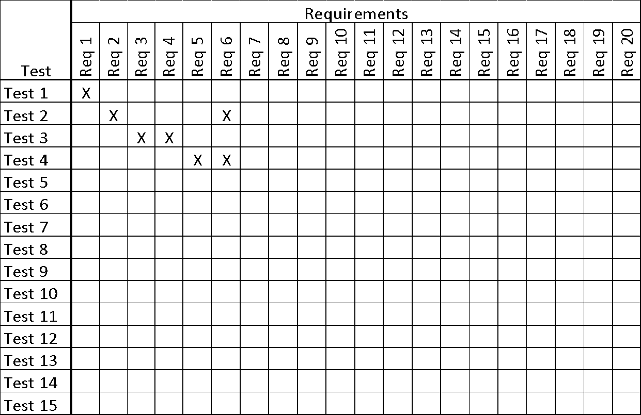

***Table 1 - Requirements - Acceptance Tests Correspondence***

### Acceptance Test Descriptions

*SV: Provide a brief description of each acceptance test. Detailed test specifications will appear in a separate document, which may be referenced here when available.*

**ID # - Name**

**Description:** Your description here . . .

# Design

## Design Goals

*SV: Identify the important design goals that are to be optimized in the proposed design.*

Your text goes here . . .

## Current System Design

*SV:* ***IF*** *the proposed new system is to replace an existing system, then the current system should be described here. Otherwise insert a brief statement that there is no pre-existing system.*

Your text goes here . . .

## Proposed System Design

*This section will make heavy use of class diagrams, and also sequence and deployment diagrams where noted. However don’t overlook finite state, activity, communication, or other diagram types as needed for effective communication.*

### Initial System Analysis and Class Identification

*SV: Perform grammatical and similar analyses to identify the most import and obviously needed classes, and to organize them into an initial class structure. An initial class diagram is appropriate, containing few if any internal details.*

Your text goes here . . .

### Dynamic Modelling of Use-Cases

*SV: Insert sequence diagrams of ( at least the most important ) use-cases, as a means of identifying other needed classes.*

Your text goes here . . .

### Proposed System Architecture

*SV: Identify the Software Architecture to be applied to this project, such as Client-Server, Repository, MVC, etc., along with justification for the choice.*

Your text goes here . . .

### Initial Subsystem Decomposition

*SV: A slightly more detailed class diagram, showing the classes identified in sections 24a, 24b, and 0 above, partitioned into subsystems. For each subsystem provide a brief description of the subsystem, including its key responsibilities. There should still be few if any internal details.*

Your text goes here . . .

## Additional Design Considerations

*SV: The sections listed here do not need to be presented in the order given, and may not all be relevant for any particular project. Those that are relevant can help identify additional classes that are needed as a result.*

### Hardware / Software Mapping

*SV: This is particularly important for distributed systems, such as those employing a client-server architecture. Use a deployment diagram to indicate which subsystems are mapped onto which piece(s) of hardware, and what communication subsystems need to be added to the system as a result.*

Your text goes here . . .

### Persistent Data Management

*SV: Document the classes and perhaps subsystems necessary to store persistent data when the system shuts down, and to restore that data when the system starts back up again.*

*Reiterate key data structures and information as necessary for the understanding of this design phase. Refer the reader back to the data dictionary in section* ***Error! Reference source not found.*** *to avoid undue repetition, while reviewing only the most relevant items here.*

Your text goes here . . .

### Access Control and Security

*SV: Identify the access control and security concerns for this system, and the new classes and/or subsystems that must be added to handle those concerns.*

Your text goes here . . .

### Global Software Control

*SV: Identify the global software control concerns for this system, and the new classes and/or subsystems that must be added to handle those concerns.*

Your text goes here . . .

### Boundary Conditions

*SV: Identify the boundary condition concerns for this system, and the new classes and/or subsystems that must be added to handle those concerns. In particular consider startup, shutdown ( normal or abnormal ), and the creation and/or maintenance of any configuration files, databases, or similar supporting data files.*

Your text goes here . . .

### User Interface

*SV: Include a preliminary user interface design here, possibly as a rough sketch or other mockup, in order to identify additional classes needed to implement the interface.*

Your text goes here . . .

### Application of Design Patterns

*SV: Any design patterns applied as a result of previous sections should have been addressed there, and identified as such at the time. Use this section to document only the additional design patterns that were not previously covered elsewhere. ( If any. )*

Your text goes here . . .

## Final System Design

*SV: Include here the final version of the overall system design, incorporating all the subsystems and classes added as a result of additional design considerations. Multiple diagrams may be needed, possibly starting with an overall package diagram showing all the different subsystems and the ( important ) classes contained within each one. Still not a lot of internal details.*

Your text goes here . . .

## Object Design

*This section documents the internal details of each class, to the extent that they can be designed at this time. Included should be the class interfaces ( public method signatures and responsibilities ) and constraints. It is probably best to break this section up into subsections corresponding to subsystems as documented above, and/or by ( Java ) packages if those are designed. It may also be appropriate to address additional design pattern considerations here, but not to the point of being redundant of previous documentation.*

*Certain methods, such as simple getters, setters, and constructors are not always documented, unless there is something special about them such as in the Singleton or Factory Method design patterns.*

### Packages

*SV: If the design involves assigning classes to packages ( .e.g Java packages ), then the packages to be created should be documented here.*

Your text goes here . . .

### Subsystem I

Your text goes here . . .

### Subsystem II

Your text goes here . . .

### etc.

Your text goes here . . .

# Project Issues

## Open Issues

*SV: Issues that have been raised and do not yet have a conclusion.*

Your text goes here . . .

## Off-the-Shelf Solutions

*SV: Discussion of products or components currently available that could either be incorporated into the new solution or simply used instead of developing ( parts of ) the new solution.  The distinction between sections 35 a, b, and c is subtle, and not very important.*

Your text goes here . . .

### Ready-Made Products

*SV: Products available for purchase that could be used either as part of a solution or instead of ( a part of ) a solution.*

Your text goes here . . .

### Reusable Components

*SV: Similar to 35a, but for components such as libraries or toolkits instead of fully blown products.*

Your text goes here . . .

### Products That Can Be Copied

*SV: Products that could legally be copied would typically be past projects developed by the same development group, provided there were no restrictions that would prevent their reuse.*

Your text goes here . . .

## New Problems

*SV: The proposed new system certainly has its benefits, but it could also raise new problems.  It is a good idea to identify any such potential problems early on, rather than being surprised by them later.*

### Effects on the Current Environment

*SV: Could the new system have any adverse effects on the working environment, e.g. the way people do their jobs?*

Your text goes here . . .

### Effects on the Installed Systems

*SV: Could the new system have any adverse effects on other hardware or software systems?*

Your text goes here . . .

### Potential User Problems

*SV: Could the new system have any adverse effects on the users of the software? Could users possibly have a negative response to the new system?*

Your text goes here . . .

### Limitations in the Anticipated Implementation Environment That May Inhibit the New Product

*SV: Are there any ( physical ) limitations in the expected environment that could inhibit the proposed product?  ( e.g. weather, electrical interference, radiation, lack of reliable power, etc. )*

Your text goes here . . .

### Follow-Up Problems

*SV: Basically any other possible problems that could occur.*

Your text goes here . . .

## Migration to the New Product

*SV: This section only applies when there is an existing system that is being replaced by a new system, particularly when data must be preserved and possibly translated / reformatted.  Otherwise just write "Not Applicable" under section 38 and remove sections 38a and 38b.*

### Requirements for Migration to the New Product

*SV: These are a list of requirements relevant to the migration procedures.  For example a requirement that the two systems be run in parallel for a time until the client is satisfied with the new system and the users know how to use it.*

Your text goes here . . .

### Data That Has to Be Modified or Translated for the New System

*SV: This section specifically addresses****data****that must be preserved and/or translated / reformatted during the migration process.*

Your text goes here . . .

## Risks

*SV: Consideration of the potential risks that could cause the project to fail / underperform.*

Your text goes here . . .

## Costs

*SV: An estimate of what it will cost to complete this project.  Think not only in terms of dollars, but also time, resources, lost opportunities, etc.*

Your text goes here . . .

## Waiting Room

*SV: This is a place to record ideas or wishes that will not be included in the current release of the product, but which might be worth reconsidering at a later date.*

Your text goes here . . .

## Ideas for Solutions

*SV: When developing requirements only, it is not the role of the business analyst to dictate the implementation of the solution.  However they can pass along any ideas they have here as suggestions to the developers.  For CS 440 this report includes system and object design, so this section would make suggestions for implementation and testing that would come after design, such as the use of a particular language, IDE, library, or other tools.*

Your text goes here . . .

## Project Retrospective

*SV: At the conclusion of the ( CS 440 ) project, reflect back on what worked well and what didn't, and how the process could be improved in the future.*

Your text goes here . . .

# Glossary

* **Host:** Similar to audience, the term host might also be a little ambiguous, as for certain events the host might also want to be an audience member with special privileges, and in other cases the host might only be able to have an overview of what is going on in the room and is able create games and other events.
* **Libraries:** Defines the code as functionalities which can be included in the applications and softwares.
* **Audience:** This can be a little vague depending on the context. For example, the host can also be an audience member, in family gatherings. But for like a sporting event the host does not have all the functionality that an audience member might have, and might have other administrative features.
* **Room:** A room is simply the place where the specific event takes place in. For example a room could be a courtroom, or a stadium.
* **Virtual environment:**  An artificial environment for users to connect and interact with each other.
* **Activities:** An activity is anything that takes place within the room. For example games that were added to the room would be considered activities.
* **Oculus:** VR headset company created by Facebook, that allows developers to make games and other VR related products.
* **Event organizer:** An event organizer can be the host, admin, or even part of the audience. The main job of the event organizer is to manage all the activities, and the setting of the room. Including inviting the audience members. The event organizer is set by the admin or the host.
* **Admin:** The admin is appointed by the host and is able to oversee all parts of the event and can also be part of the audience. The admin can be the host, event organizer, and even the audience member.
* **Full-text search:** A way to store full-text documents in a way that is easy to search and retrieve.
* **Database:** A way to organize and store persistent data in an organized manner that is easy to manage and retrieve.
* **Data structures:** Similar to a database, but holds small amounts of data that is not persistent.
* **Event organizer:** An event organizer is a term used to describe all parties that helped in organizing the event. An admin, host, event organizer are all considered event organizers.
* **Event:** An event can be used to describe a room, and can be used interchangeably.

.

# References / Bibliography

*This section describes the documents and other sources from which information was gathered. This sample bibliography was generated using the “Insert Citation” and “Bibliography” buttons in the “Citations & Bibliography” section under the “References” tab of MS Word. Creating new citations will not update this list unless you click on it and select “Update Field”. You may need to reset the style for this paragraph to “normal” after updating.*

|  |  |
| --- | --- |
| [1] | Robertson and Robertson, Mastering the Requirements Process. |
| [2] | A. Silberschatz, P. B. Galvin and G. Gagne, Operating System Concepts, Ninth ed., Wiley, 2013. |
| [3] | J. Bell, "Underwater Archaeological Survey Report Template: A Sample Document for Generating Consistent Professional Reports," Underwater Archaeological Society of Chicago, Chicago, 2012. |
| [4] | M. Fowler, UML Distilled, Third Edition, Boston: Pearson Education, 2004. |

# Index

*This section provides an index to the report. The sample below was generated using the “Mark Entry” and “Insert Index” items from the “Index” section on the “References” tab, and can be automatically updated by right clicking on the table below and selecting “Update Field”. To remove marked entries from the document, toggle the display of hidden paragraph marks ( the paragraph button on the “Home” tab ), and remove the tags shown with XE in { curly braces. }*

Design 61, 63

Requirements 35, 51, 58

Test 64, 65